Adactin Automation Test Execution Report
Generated On: 3/28/2026, 2:12:22 PM
Execution Command: npx playwright test --reporter=json
Exit Code: 0

Execution Summary
Total Tests | 11
Passed | 11
Failed | 0
Skipped | 0

Detailed Test Cases

Test Case 1
Test Case No | TC-001
Scenario | e2e\e2e_booking.spec.js > E2E booking flow: login, search, select, book, itinerary, logout
Expected Result | User should be logged out successfully and see logout confirmation.
Actual Result | All assertions passed. Test executed successfully.
Pass/Fail | PASS
Source File | e2e/e2e_booking.spec.js
Screenshot | test-finished-1.png  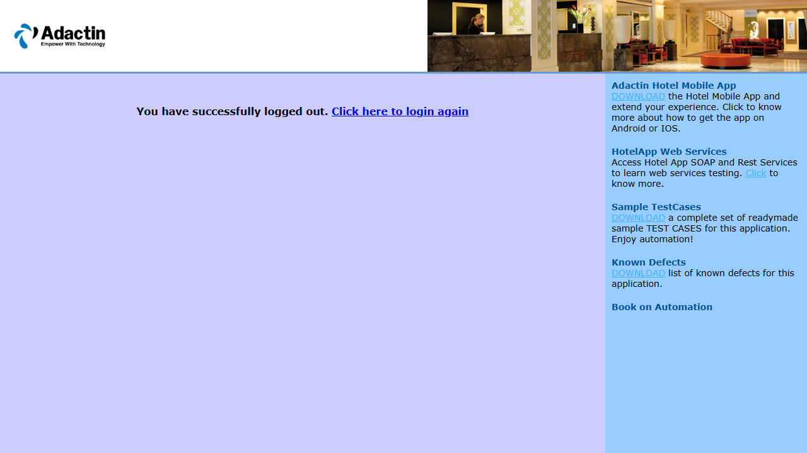

Test Case 2
Test Case No | TC-002
Scenario | negative\negative_booking_missing_firstname.spec.js > Negative: booking without first name shows required field error
Expected Result | System should block invalid flow and display the expected validation or authorization message.
Actual Result | All assertions passed. Test executed successfully.
Pass/Fail | PASS
Source File | negative/negative_booking_missing_firstname.spec.js
Screenshot | test-finished-1.png  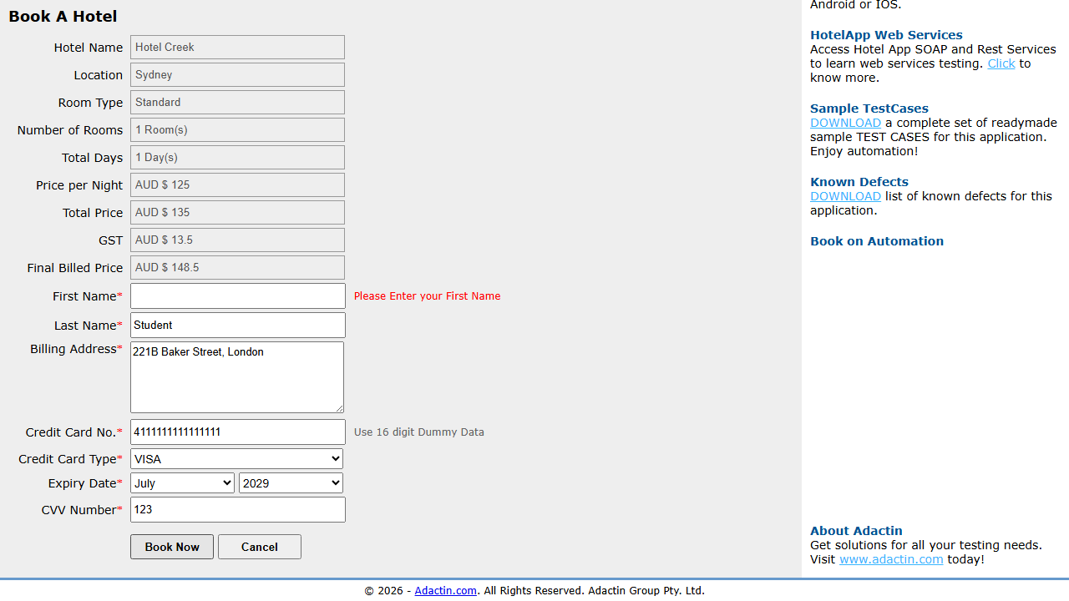

Test Case 3
Test Case No | TC-003
Scenario | negative\negative_invalid_credit_card.spec.js > Negative: invalid credit card length and missing CVV show validation
Expected Result | System should block invalid flow and display the expected validation or authorization message.
Actual Result | All assertions passed. Test executed successfully.
Pass/Fail | PASS
Source File | negative/negative_invalid_credit_card.spec.js
Screenshot | test-finished-1.png  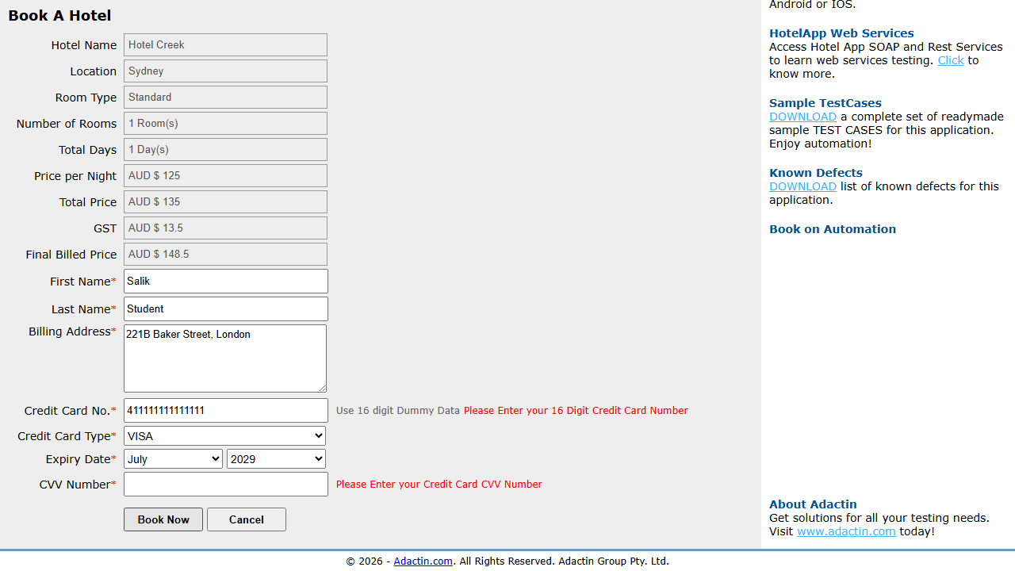

Test Case 4
Test Case No | TC-004
Scenario | negative\negative_invalid_login.spec.js > Negative: invalid login shows exact error message
Expected Result | System should block invalid flow and display the expected validation or authorization message.
Actual Result | All assertions passed. Test executed successfully.
Pass/Fail | PASS
Source File | negative/negative_invalid_login.spec.js
Screenshot | test-finished-1.png  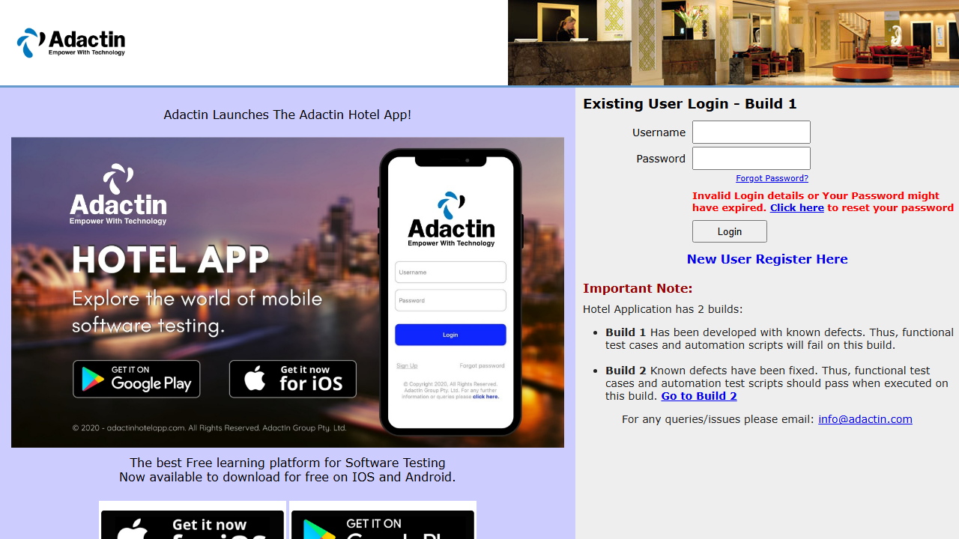

Test Case 5
Test Case No | TC-005
Scenario | negative\negative_search_missing_location.spec.js > Negative: search without mandatory location shows validation
Expected Result | System should block invalid flow and display the expected validation or authorization message.
Actual Result | All assertions passed. Test executed successfully.
Pass/Fail | PASS
Source File | negative/negative_search_missing_location.spec.js
Screenshot | test-finished-1.png  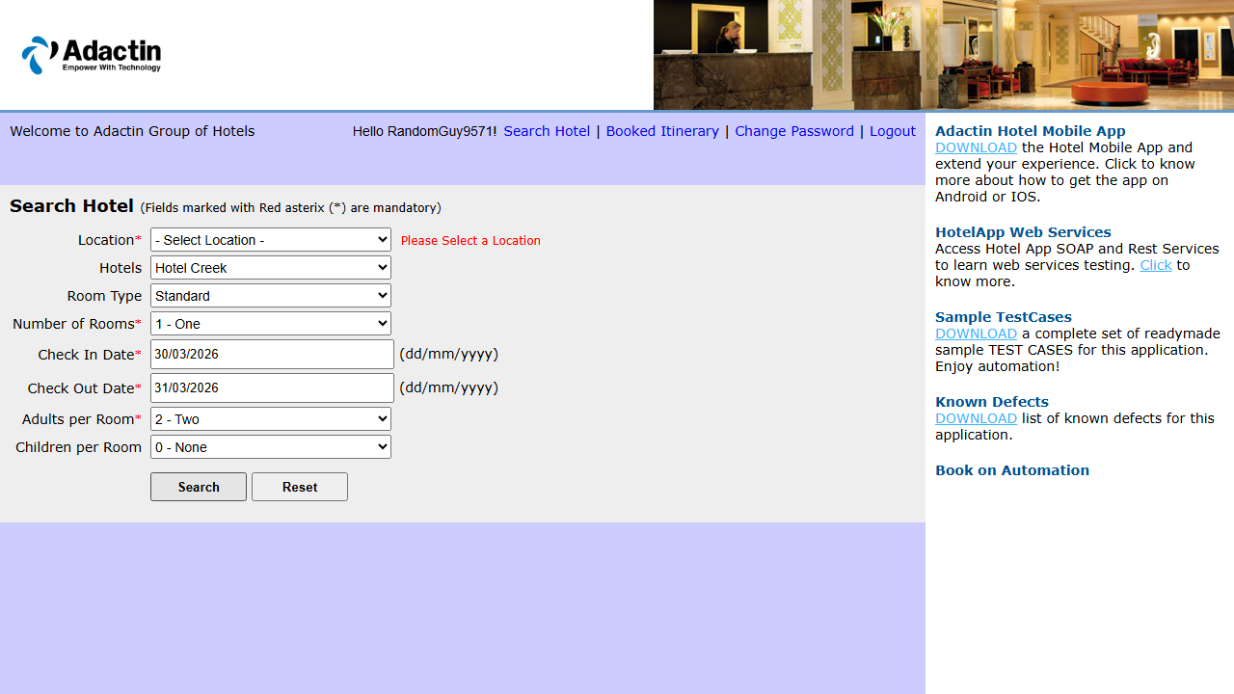

Test Case 6
Test Case No | TC-006
Scenario | negative\negative_unauthorized_access.spec.js > Negative: direct access without login redirects to login page
Expected Result | System should block invalid flow and display the expected validation or authorization message.
Actual Result | All assertions passed. Test executed successfully.
Pass/Fail | PASS
Source File | negative/negative_unauthorized_access.spec.js
Screenshot | test-finished-1.png  

Test Case 7
Test Case No | TC-007
Scenario | positive\positive_booking_confirmation.spec.js > Positive: booking flow reaches Booking Confirmation page
Expected Result | End-to-end booking should complete successfully with valid order creation and verification.
Actual Result | All assertions passed. Test executed successfully.
Pass/Fail | PASS
Source File | positive/positive_booking_confirmation.spec.js
Screenshot | test-finished-1.png  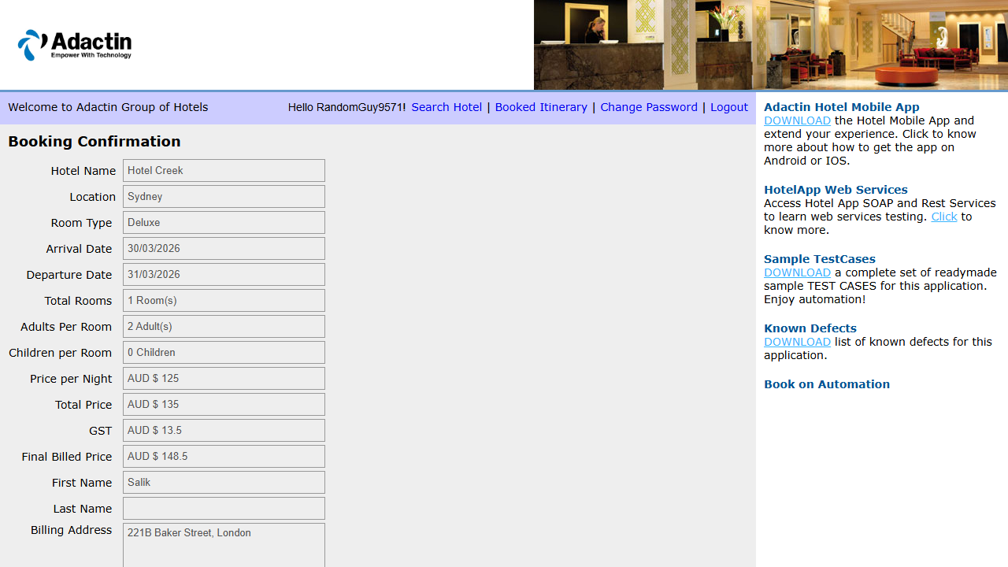

Test Case 8
Test Case No | TC-008
Scenario | positive\positive_login.spec.js > Positive: successful login with valid credentials
Expected Result | User should log in successfully and be redirected to the hotel search page.
Actual Result | All assertions passed. Test executed successfully.
Pass/Fail | PASS
Source File | positive/positive_login.spec.js
Screenshot | test-finished-1.png  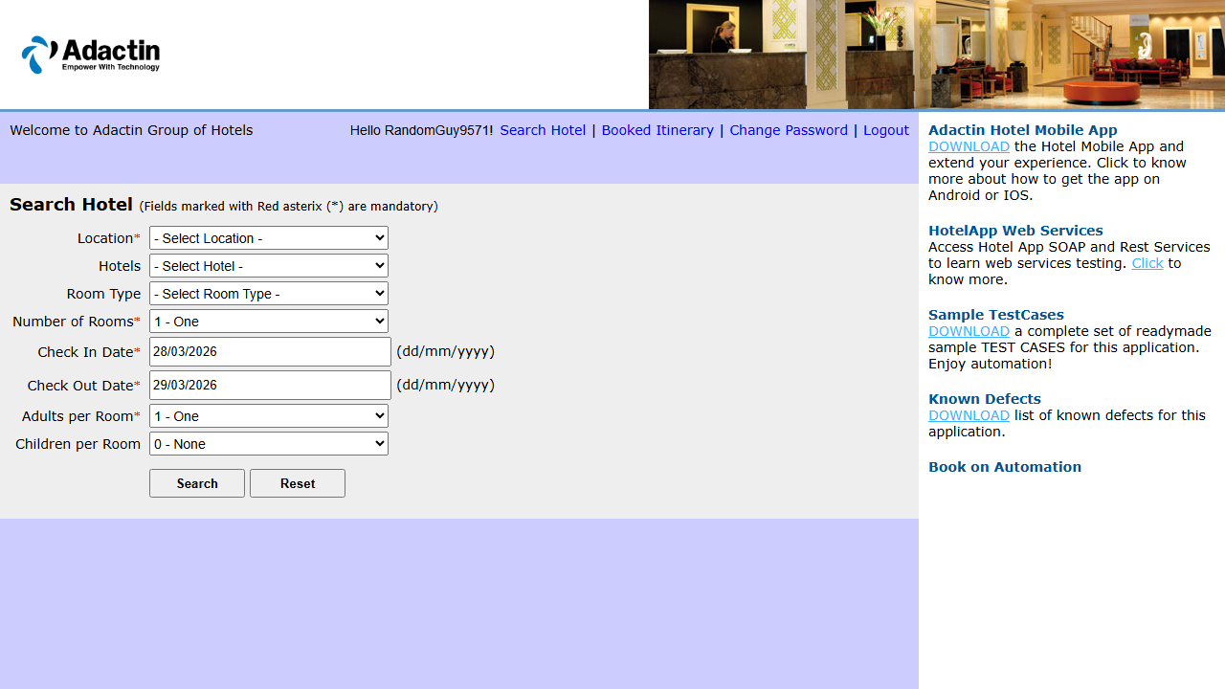

Test Case 9
Test Case No | TC-009
Scenario | positive\positive_logout.spec.js > Positive: successful logout after login
Expected Result | User should be logged out successfully and see logout confirmation.
Actual Result | All assertions passed. Test executed successfully.
Pass/Fail | PASS
Source File | positive/positive_logout.spec.js
Screenshot | test-finished-1.png  

Test Case 10
Test Case No | TC-010
Scenario | positive\positive_search.spec.js > Positive: valid hotel search shows Select Hotel page
Expected Result | Search flow should navigate to the next expected screen with valid criteria.
Actual Result | All assertions passed. Test executed successfully.
Pass/Fail | PASS
Source File | positive/positive_search.spec.js
Screenshot | test-finished-1.png  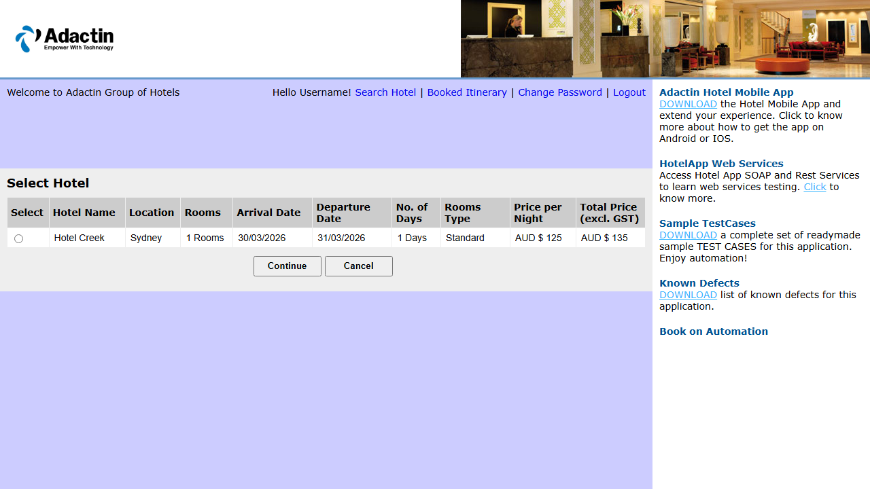

Test Case 11
Test Case No | TC-011
Scenario | positive\positive_selection.spec.js > Positive: successful hotel selection navigates to Book A Hotel page
Expected Result | Application should behave as expected for this scenario without assertion failures.
Actual Result | All assertions passed. Test executed successfully.
Pass/Fail | PASS
Source File | positive/positive_selection.spec.js
Screenshot | test-finished-1.png  